**Training Programs & Workshops**

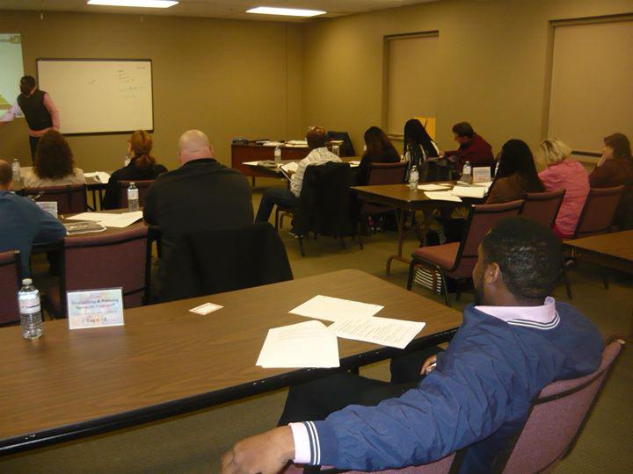

In **Living an Effective Lifestyle Inc.,** our training sessions are prepared meticulously by our trainers and course designers specially designed in a manner geared towards the maximization of efficiency.

We believe your time is valuable, and so is ours, so our goal is to best prepare the course participants while taking up the least amount of their time possible.

Our training programs and workshops are crafted to use a blend of classroom discussions, case studies, in-class Assignments, and participant interaction with formal role-plays to ingrain the concepts into the participant's heart and mind.

Our program format is a powerful way to help delegates understand complex ideas and, most importantly, develop a common understanding and approach to using theories and applying tools to make a real difference in the performance of their responsibilities. Case studies and materials will target and build on real-life scenarios out of the life, family and work environment.

Our training programs and workshops are usually conducted by one of our top trainers and our training session comprises of lectures, assignments, activities and actual role plays that will touch upon the subject matters

**Certification**

At the end of the program, participants will receive a formal certificate from Living an Effective Lifestyle Inc. – recognizing their participation and completion of the training.

**Venues**

All our programs can be offered on-site or off-site. The respective location for each course will be communicated when applicable.

**Who Should Attend**

Living an Effective Lifestyle Inc., Training programs and workshops are designed and suitable for all cadres of Leadership, whether small, medium or large size organizations, Churches, Heads of Departments, Coordinators, Supervisor, individuals and business professionals who want to increase accountability to defined personal goals and achieve better results.

**See a few of our most attended signature training workshops below:**

**Goal Setting Signature Program™**

As Patch Adams rightly said... You've got to know what you want. This is central to acting on your intentions. When you know what you want, you realize that all that is left then is time management. You'll manage your time to achieve your goals because you clearly know what you're trying to achieve in your life. *Continued…*

**Unlocking Your Confidence & Inner Strength Signature Program™**

A healthy self-esteem is essential for growth and achieving success. Of all the

judgments an individual make in life, none is as important as the one they make about themselves. Without some measure of self-worth, life can be painful and unrelenting. *Continued…*

**Emotional Insight Signature Program™**

Emotional insight, also called EQ or emotional intelligence, is the ability to be aware of and to manage emotions and relationships. It’s a pivotal factor in personal and professional success. IQ will get you in the door, but it is your EQ, your ability to connect with others and manage the emotions of yourself and others, that will determine how successful you are in life. *Continued…*

**Becoming a Competent Reaper Signature Program™**

Becoming a Competent Reaper is a practical seminar for understanding how to REAP and become good Reapers.

Many believers are of the mindset that reaping is automatic, just sow and you will reap, however, now farmer just sows and then goes out to reap because there are certain preparations that he or she must put in place to guarantee a harvest. *Continued…*

**Take Charge: ADVANCE Signature Program™**

Why are there so many different organizational systems and time management methods out there? The answer is simple: it’s like any other personal challenge, like weight loss or money management. There is no simple, one size fits all answer. You must build a solution that works for you. *Continued…*

Please note that you will have to inquire which of the program is currently scheduled to enable you to enroll before enrollment close. To be notified when the next group becomes open, please click here or email: [info@livinganeffectivelifestyle.com](mailto:info@livinganeffectivelifestyle.com)

.